Thermal Wind balance Tutorial/Assignment

## Timothy Allen 66522411

1. Values a, b1 and zT were set as global variables. A set of 1000 points was used to represent latitudes between -90 and 90 degrees and 1000 points for altitudes between 22 and 0 km. These were passed to a function that formed a mesh grid for fast calculations. The coefficient b was calculated using $b=b_{1}⋅\left(1-\frac{z}{z_{T}}\right).$ Temperatures were then calculated using $T=a+b\left[\frac{3}{2}⋅\left(\frac{2}{3}+sin^{2}\left(ϕ\right)\right)⋅cos^{3}\left(ϕ\right)\right]$ (ensuring $ϕ$ in units of degrees for NumPy). This was then plotted as a heatmap using Matplotlib’s “imshow” function with “extent” from -90 to 90 and 0 to 22. A colour bar was set up and the plot was labelled and formatted producing Fig.1.

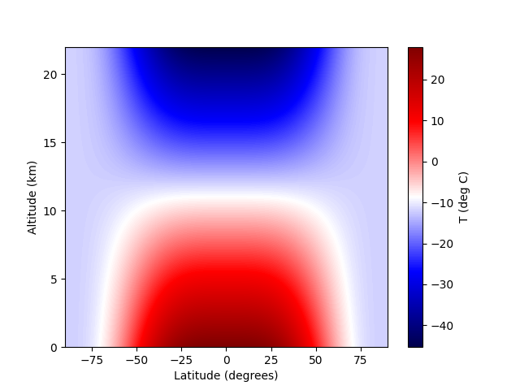

Fig. 1: Heatmap of temperature as a function of latitude and altitude

1. Gravity and omega (rotation rate of the Earth) were set as global variables. Temperatures were adjusted to Kelvin and the gradient of temperature with respect to latitude (in km) was taken. The Coriolis parameter f was calculated from $f=2Ωsin\left(ϕ\right)$. The derivative of wind speed with respect to altitude was calculated from the thermal wind shear balance equation $\frac{∂u}{∂z} = -\frac{g}{fT} \frac{∂T}{∂ \backslash phi }$. Then Eulers method was performed using the step size as difference between altitude values and multiplying this by the cumulative sum of the derivatives starting at zero altitude (where wind speed was assumed 0). This produced the wind speeds in metres per second, this was plotted as aheatmap with matplotlib’s “imshow” function with “extent” from -90 to 90 and 0 to 22. A colour bar was set up, values where the thermal wind shear balance equation break down (between -20 and 20 degrees latitude) were blacked out (see Fig.2) and cut out (see Fig.3) and the plots were labelled and formatted.

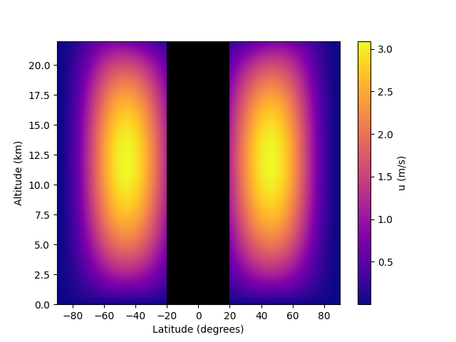

Fig.2: Heatmap of windspeeds as a function of latitude and altitude with invalid speeds around the equator blacked out.

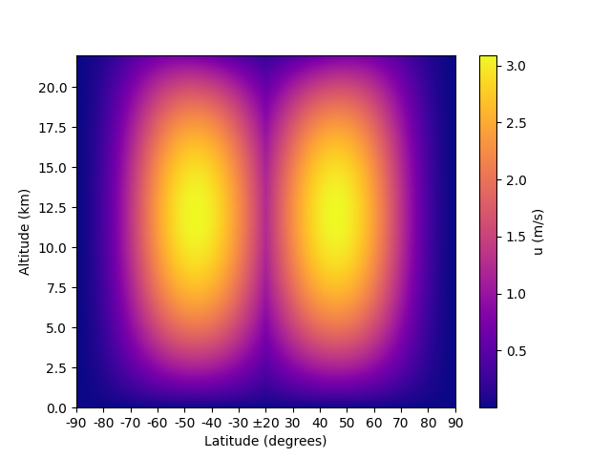

Fig.2: Heatmap of windspeeds as a function of latitude and altitude with invalid speeds around the equator cut out.